How to create Robust system in .net core
1)Design the application using modular component
2)leverage .net core built in DI container to manage component dependencies
3)optimizer i/o operation
4)implement caching for frequently used data
5)implement authentication and authorization for security
6)implement logging framework for debugging and performance monitoring
7)implement a combination of unit tests and integration test to validate code functionality

How to Preventing System crashes
1)Global Exception handling using custom middleware
2)Proper disposal of unmanaged resources
3)Implement Retry and Timeout policies to prevent indefinite waiting
4)Implement Async programming to prevent blocking operation
5)Implement logging and monitoring for debugging and analysis
6)Regular updates and Patching of existing packages

how to culture fit with Client
1)Be clear and concise-Use simple, direct language and speak at a steady pace.
2)Use visuals: Supplement verbal communication with diagrams, charts, and
other visuals to explain complex ideas more effectively.
3)Research about client's culture
4)Promote open communication: feel safe to ask clarifying questions and raise concerns without fear of judgment.
5)Maintain transparency and regular contact
6)Focus on client solutions

Client requirements process:
1)Define project goals
2)Identify stakeholders
3)Prepare for meeting
4)Focus on understanding the client's needs by listening carefully to their verbal and non-verbal cues.
5)Don't make assumptions. If something is unclear,
ask questions to confirm your understanding and
verify your interpretation of their business processes.
6)Document everything: Record all requirements, assumptions,
and decisions made during the meeting in a clear, transparent, and organized manner.
7)Review and confirm: Share the documented requirements with the client to ensure everyone has a shared and
accurate understanding. Ask for confirmation on any ambiguities.

8)Internal review:Discuss the gathered requirements with your project team to ensure a
common understanding before proceeding.

9)Finalize and approve:finalize the requirements document, and obtain formal approval from the client.

Pipeline issue

1)Syntax erros:missing semicolons, incorrect variable names

2)Unit or integration tests failing due to broken code,
incorrect configurations, or dependency mismatches

3)Pipeline lacking necessary permissions to access resources

4)Incorrect or missing dependencies

5)Environment Differences

6)Jobs or tasks exceeding their configured timeout limits

Difference between HLD and LLD:
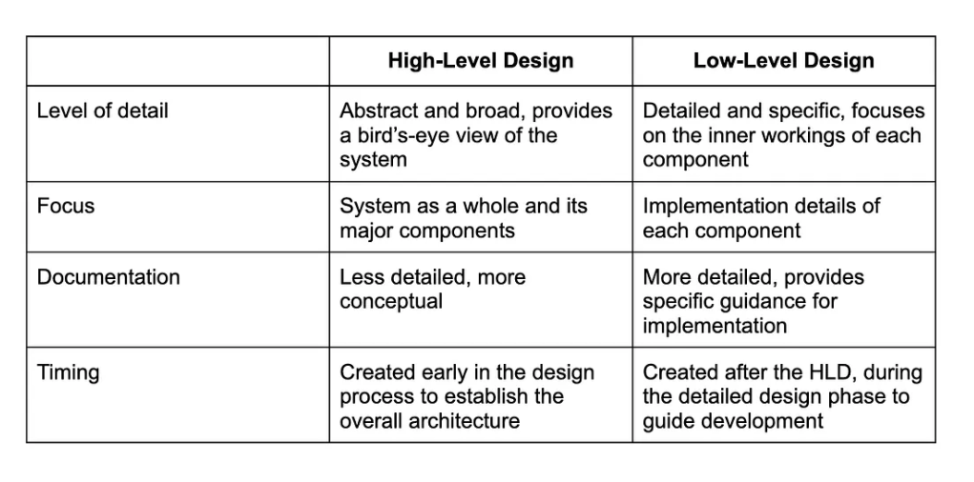

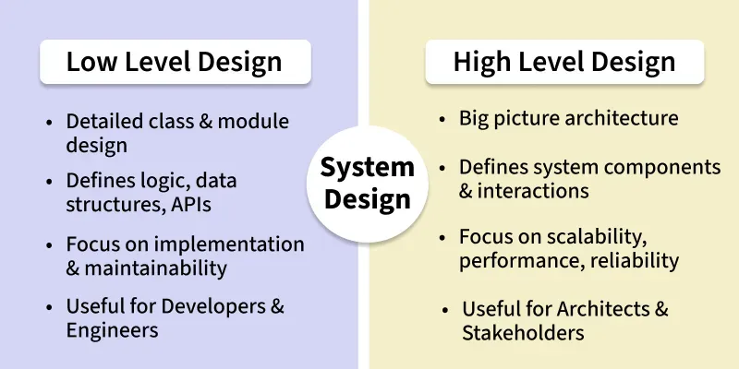

Preventing system crashes in .NET Core applications involves a multi-faceted approach focusing on robust error handling, resource management, and application architecture.
1. Robust Error Handling:
- Global Exception Handling:
Implement centralized error handling using middleware (e.g., UseExceptionHandler or custom middleware) to catch unhandled exceptions, log them, and provide user-friendly error responses (e.g., Problem Details for APIs).
- Structured Exception Handling:
Utilize try-catch-finally blocks to handle expected exceptions, recover from errors where possible, and ensure resource cleanup.
- Specific Exception Handling:
Catch and handle specific exception types (e.g., OperationCanceledException for cancellation) rather than relying solely on generic exception handling.
2. Efficient Resource Management:
- Memory Management:
  - Avoid allocating large, short-lived objects on hot code paths.
  - Consider caching large, frequently used objects.
  - Use ArrayPool<T> for pooling large arrays to reduce allocations.
  - Monitor garbage collection (GC) performance using tools like PerfView to identify memory pressure.
- Resource Disposal:
Ensure proper disposal of disposable resources (e.g., database connections, file streams) using using statements or explicit Dispose() calls.
3. Application Architecture and Design:
- Circuit Breaker Pattern:
Implement the circuit breaker pattern, especially in microservices architectures, to prevent cascading failures by isolating failing services and providing graceful degradation.
- Retry and Timeout Policies:
Implement retry mechanisms for transient failures and set appropriate timeouts for external service calls to prevent indefinite waiting.

- Asynchronous Programming:
Utilize asynchronous programming (async/await) to improve responsiveness and prevent blocking operations, which can lead to resource exhaustion.
- Load Testing and Monitoring:
Conduct load testing to identify performance bottlenecks and potential crash points under stress. Implement comprehensive monitoring and logging to detect issues early and gain insights into application behavior.
4. External Factors:
- Hardware and Environment:
Ensure adequate hardware resources, proper ventilation to prevent overheating, and a stable operating environment.
- Software Updates:
Keep the .NET Core runtime, libraries, and operating system updated to benefit from bug fixes and performance improvements.
- Dependency Management:
Carefully manage third-party dependencies, ensuring compatibility and addressing any known vulnerabilities.

To deal with misunderstandings with international clients:
Improve communication
- Be clear and concise: Avoid slang, idioms, and technical jargon that may not translate well. Use simple, direct language and speak at a steady pace.
- Paraphrase and check for understanding: After a client speaks, restate what you heard in your own words to confirm you've understood correctly. Likewise, when you speak, ask the client to paraphrase to ensure they've grasped your meaning.
- Use visuals: Supplement verbal communication with diagrams, charts, and other visuals to explain complex ideas more effectively.
- Write it down: Document all key decisions and agreements in writing to have a clear record and prevent future disputes. This also creates a fallback if verbal communication is unclear.
- Minimize language barriers: Even if English is a common business language, be aware of different fluency levels. Speak slowly, pause frequently, and be prepared to repeat or rephrase points.
Build cultural awareness
- Research your client's culture: Before meetings, take time to research cultural norms around communication, business etiquette, and even how decisions are made.
- Avoid stereotypes: Don't make assumptions about an individual based on their nationality or cultural background; treat everyone as an individual.
- Promote open communication: Create a company culture where team members feel safe to ask clarifying questions and raise concerns without fear of judgment.
- Show curiosity: Instead of assuming, ask respectful questions to learn about their perspective, such as, "How do you typically approach this in your culture?".
Manage the relationship
- Be patient and flexible: Recognize that cultural differences can lead to different approaches and timelines. Be patient with potential delays and be flexible in your approach to communication and problem-solving.
- Establish clear agreements: Set clear expectations upfront through detailed work agreements, including payment terms and currency, to prevent misunderstandings later.
- Maintain transparency and regular contact: Keep clients updated on progress and make an effort to have regular check-ins, especially to compensate for the lack of face-to-face meetings.
- Focus on solutions: When issues arise, address them quickly by listening to the client's concerns and working toward a mutual solution.

